Tata Data Visualisation:
Empowering Business With Effective insights

Data Analysis and Business Insights Documentation


Business Performance Analysis and Expansion Insights for Online Retail Store
An online retail store has hired you as a consultant to review their data and provide insights that would be valuable to the CEO and CMO of the business. The business has been performing well and the management wants to analyse what the major contributing factors are to the revenue so they can strategically plan for next year.
The leadership is interested in viewing the metrics from both an operations and marketing perspective. Management also intends to expand the business and is interested in seeking guidance into areas that are performing well so they can keep a clear focus on what’s working. They would also like to view different metrics based on the demographic information that is available in the data.
A meeting with the CEO and CMO has been scheduled for next month and you need to draft the relevant analytics and insights that would help evaluate the current business performance and suggest metrics that would enable them to make the decision on expansion.
Remember, thinking from the perspective of business leaders allows you to analyse the data more effectively and present better insights.
Access the links in the resources below to better understand how business leaders think and approach business performance.
Task 1:
To prepare for your meeting, you need to draft questions that you think will be important and relevant to the CEO and CMO. This preparation will be your guide as you develop your presentation.
For this task, you are only required to draft the questions. Make sure to think both quantitatively and qualitatively.
You’ve been provided a dataset in the resources below to use as the basis for your exploration. Review this data, taking note of what information has been provided, what insights you can garner, and what is relevant to both the CEO and CMO respectively.
Create a set of four questions that you anticipate each business leader will ask and want to know the answers to. Make sure you differentiate your questions, as both the CEO and CMO view business decisions through different lenses.

Solution:
Questions of interest to the CEO
Which region is generating the highest revenue, and which region is generating the lowest?
This question is important to the CEO as it is based on the fundamental source of income for the business, i.e., revenue. Revenue analysis is important to the CEO as top-level executives are always focused on earnings and how to increase it. Here, the CEO is interested in the viewing revenue by the regions, to assess which regions are generating the highest revenue and which regions are generating lower revenue. Using the data and analysis, the CEO will be able to decide on how to further generate revenue in the regions that are already generating the most revenue. For the regions that are not generating enough revenue, the CEO will then study the reasons why there is a lack of sales in those regions and try to improve the products and make them more suitable for those regions.
What is the monthly trend of revenue, which months have faced the biggest increase/decrease?
A monthly trend of revenue will provide the CEO with insights on how the revenue is fluctuating each month. This will enable the CEO to analyze how the internal changes inside the company have had impact on the sales. E.g., how a new product launch has led to an increase in revenue during the month or how the introduction of a new region has led to an increase in revenue for the online store. The CEO can also analyze if there have been any delays internally that would have caused a potential decrease. Such analysis is vital for the senior management as it would enable them to plan ahead and try to make the customer experience as smooth as possible.
Which months generated the most revenue? Is there a seasonality in sales?
In retail businesses, there are always months that will have a greater demand due to seasonality. There will be cases where the data will experience regular and predictable changes that recur every calendar year. Such seasonal months would be necessary to identify as the CEO would be interested in devising a strategy that would gain the maximum benefit from the months that have greater demands.
Who are the top customers and how much do they contribute to the total revenue? Is the business dependent on these customers or is the customer base diversified?
This analysis is highly important as it would enable the CEO to identify what the main drivers are behind the total revenue. Looking at the top customers of the retail store would provide an idea of which customers arecontributing the most to the revenue. The store can then derive a strategy where the top customers can be targeted with more products that they can buy. This will ensure higher revenue for the store as these customersare the top buyers from the store. Although having fewer customers buying in high volumes can be beneficial for a business, there can also be a drawback. Retailers would have less bargainingpower with these customers because they drive the majority of the revenue for the store and can negotiate lower prices. The CEO needs to be notified of the diversification of the customers so that he can plan ahead of time. In cases wehre the business is highly dependent on a few customers, the plan would be to increase the customer base and target more customers that would bring more revenue to the store.
Questions of interest to the CMO
What is the percentage of customers who are repeating their orders? Are they ordering the same products or different?
This question shows that the CMO is interested in viewing the trends in customer orders. He is interested to know how many customers out of the total are coming back to them and re-ordering. This analysis will help explain to the CMO what percentage of customers are buying from them more than once. Once this is identified, the CMO can come up with a strategy to target these customers with more offers and products that they would need. The analysis will also be done to see what they are buying the second time, this will provide the CMO trends into what products and sub products are in demand and then a marketing strategy can be devised to target these customers with better options.
For the repeat customers, how long does it take for them to place the next order after being delivered the previous one?
This analysis will help the CMO identify the frequency of orders. This would mean determining how long the customers are taking to re-order from the store. The expectation is that those customers who have recently made a purchase would have the product on their mind and are expected to purchase or use the product again in the future. Once the information is gathered from the analysis, the CMO can create a strategy to get the recent customers to revisit the business and spend more. For the customers who have not made purchases again from the store, efforts can be made to remind them that it has been a while since they last purchased from the store. Incentivizing customers also comes into play in this scenario.

What revenue is being generated from the customers who have ordered more than once?
Revenue stems from how much the customer spends to purchase the products from the store. Therefore, the analysis needs to be done to determine how much revenue is being generated from the customers who are regular buyers from the store. The CMO can devise a strategy to encourage customers who spend more money on repeat purchases to continue to do so. It is also important to note that if a customer has made a big purchase the first time, they should be encouraged to come and shop from the store again. A marketing strategy will ensure that the high paying customers will continue to bring more revenue to the store going forward, as well.
Who are the customers that have repeated the most? How much are they contributing to revenue?
It is also important to assess which customers are repeating the most and how much are they contributing to the revenue. There would be customers who need the same products on a weekly or monthly basis, however, the products do not have a high monetary value. Therefore, the contribution to revenue for these customers will be low. On the other hand, there might be customers who are ordering twice a year and have very big orders in terms of revenue. These customers buy on certain months only, therefore, the management needs to ensure that enough supplies are available to accommodate their orders. The customers will high order volumes and low revenue would need to be offered more discounts so that they can buy in bulk and lead to more revenue.
Task2:
You have been asked by the CEO and CMO to provide visuals on the metrics that they wish to analyse for the online retail store. You will gather the requirements and provide them with the type of visual that would be best suited to the scenario. The senior management wants to understand how their business is performing and what areas are the key strengths of the company. They are also focused on identifying opportunities that would lead to growth and generate more revenue in the future.
You will be provided multiple visualisation requests by the CEO and you would need to provide the visual which would explain the data and insights in the simplest possible manner. The visual should adequately convey the information that you are trying to present. This exercise is critical to the senior management as any incorrect representation can lead to a wrong message being conveyed, or a wrong decision taken by the management. Therefore, you would need to make sure that the correct visuals are used to represent each set of data.
n this task, you will be required to read the questions carefully and understand that business requirement. Once you have an idea of what is required from the perspective of the CEO and CMO, you will need to come up with the perfect visual which will illustrate what the senior managers are looking for in each scenario. Remember, data can be presented in multiple types of charts, but you are required to select the visual that would best display the information which is being presented.
You will be provided resources on how to select visuals based on the different scenarios, these are available in the resources below. These resources will help you get an idea on which visual to select for the given business scenario and will also guide you on how to choose the right chart or graph for your data. Each question will contain a unique scenario and you will be expected to answer the questions based on that scenario.
Grammar of Graphics to understand the dimensions of visuals.
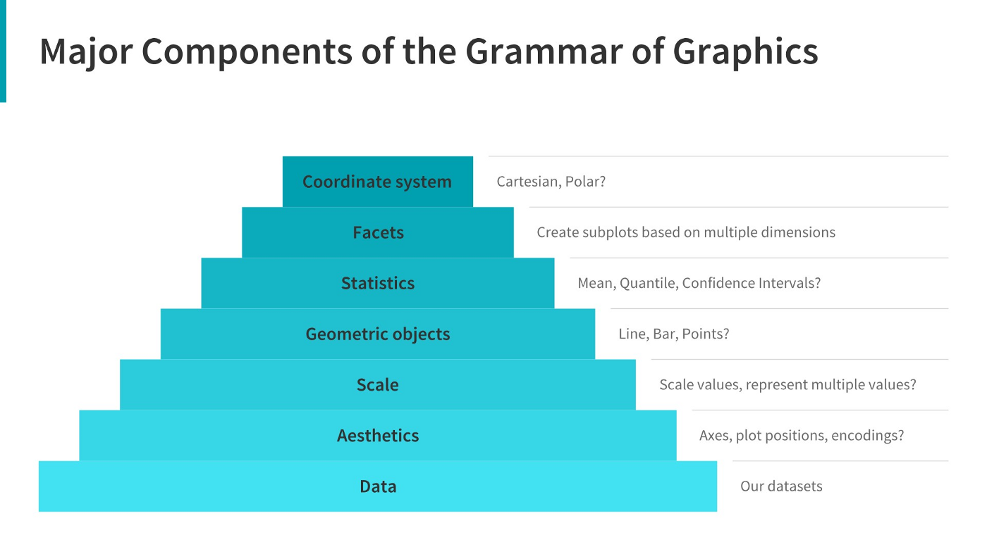

Choosing right charts based upon need such as Comparison, Distribution, Relationship, and Composition.
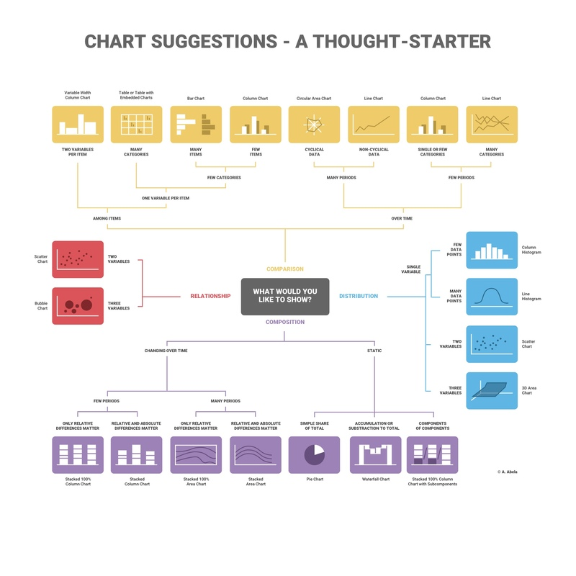https://www.analyticsvidhya.com/blog/2021/09/how-to-choose-the-right-chart-for-data-visualization/
TASK3:
The CEO and CMO have recently met to finalise the requirements and would like you to provide them with some analysis and visuals that would help answer their questions. Both, the executives are interested in viewing and understanding how they can use the data to make more meaningful decisions. You would need to provide insights which they can use to create the expansion strategy. The executives want to analyse the trends and the breakdown by different categories so that they have clarity on how the revenue is being generated and what are the main factors affecting the online store.
You will be provided with the requirements of the executives and how they want to view the data. After the requirement gathering phase, you would need to make sure that the data you are using is of good quality and does not contain any bad data that would have an adverse impact on your analysis. Once the data is cleaned, the next step would be to create the visuals on either Tableau or Power BI. No matter which tool you choose for the visuals, the result should be the same. These results will help the executives with effective decision making and assist in their expansion strategy.
In this task, you will create the visuals around four of the questions that the CEO and CMO have requested. You can use either Tableau or Power BI to create the visuals and we’ve provided the data in the resources below.
Data cleanup
Before you can begin the analysis, make sure that the data is cleaned properly. You have noticed that the data contains some returns to the store which are provided in negative quantities and there are unit prices which were input in error. You will need to perform the following steps to clean this data.
- Create a check that the quantity should not be below 1 unit
- Create a check that the Unit price should not be below $0
Please note that in order to apply the checks that have been mentioned above, you would need to use conditional formulas where the logic would state that if the conditions are met then the tool should exclude the data from analysis. You can also use data transformation methods to get rid of the bad data. Both these methods are provided in the resources. Once this is done, the data will be good to be used for further analysis. Please note that this data should be cleaned up before attempting any question.Create each visual on a separate tab with the name of the tab displaying the question number. Once the visuals are created, save the files and upload them below. For Tableau users, you would need to upload in .twbx format whereas Power BI files need to be saved in .pbix format. Instructions on how to save in these formats are provided in the resources below.

Data set: ..\Downloads\Online Retail.xlsx
Solution
Question 1
The CEO of the retail store is interested to view the time series of the revenue data for the year 2011 only. He would like to view granular data by looking into revenue for each month. The CEO is interested in viewing the seasonal trends and wants to dig deeper into why these trends occur. This analysis will be helpful for the CEO to forecast for the next year.
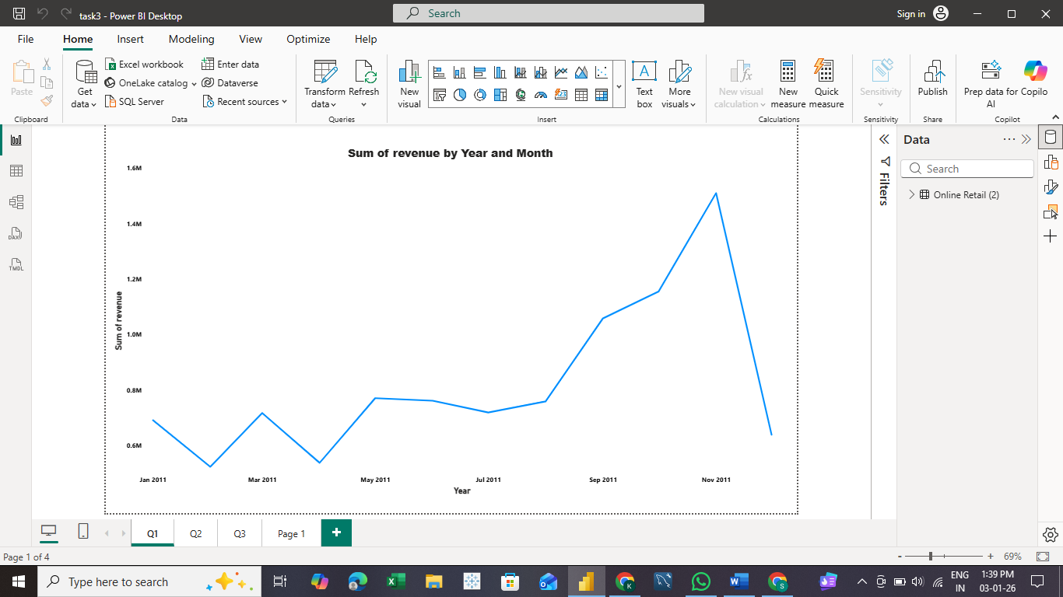
Question 2
The CMO is interested in viewing the top 10 countries which are generating the highest revenue. Additionally, the CMO is also interested in viewing the quantity sold along with the revenue generated. The CMO does not want to have the United Kingdom in this visual.
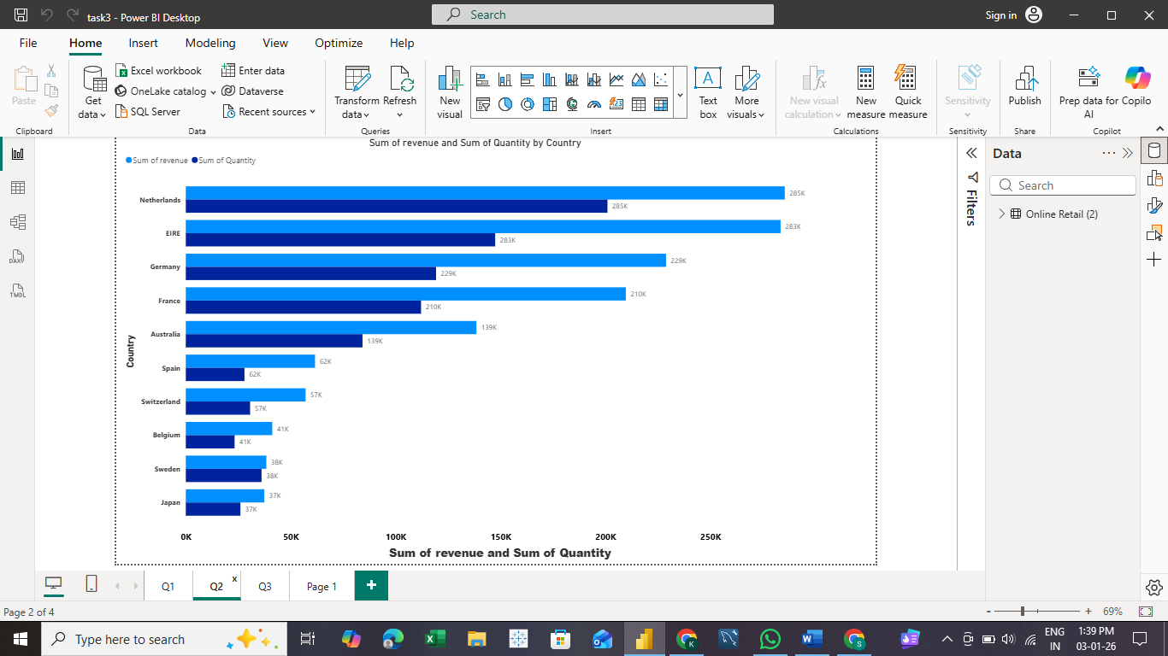

Question 3
The CMO of the online retail store wants to view the information on the top 10 customers by revenue. He is interested in a visual that shows the greatest revenue generating customer at the start and gradually declines to the lower revenue generating customers. The CMO wants to target the higher revenue generating customers and ensure that they remain satisfied with their products.

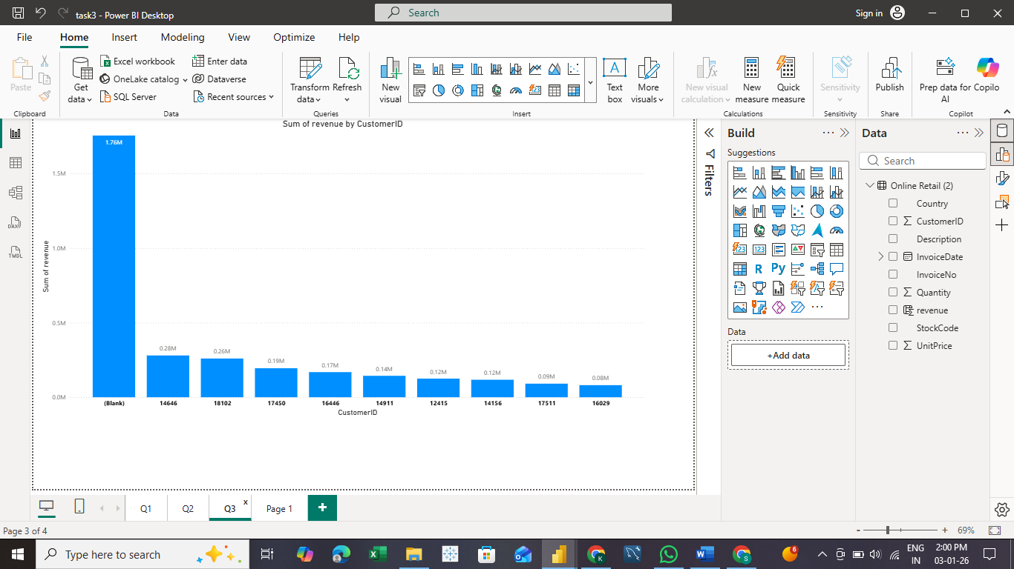
Question 4
The CEO is looking to gain insights on the demand for their products. He wants to look at all countries and see which regions have the greatest demand for their products. Once the CEO gets an idea of the regions that have high demand, he will initiate an expansion strategy which will allow the company to target these areas and generate more business from these regions. He wants to view the entire data on a single view without the need to scroll or hover over the data points to identify the demand. There is no need to show data for the United Kingdom as the CEO is more interested in viewing the countries that have expansion opportunities.
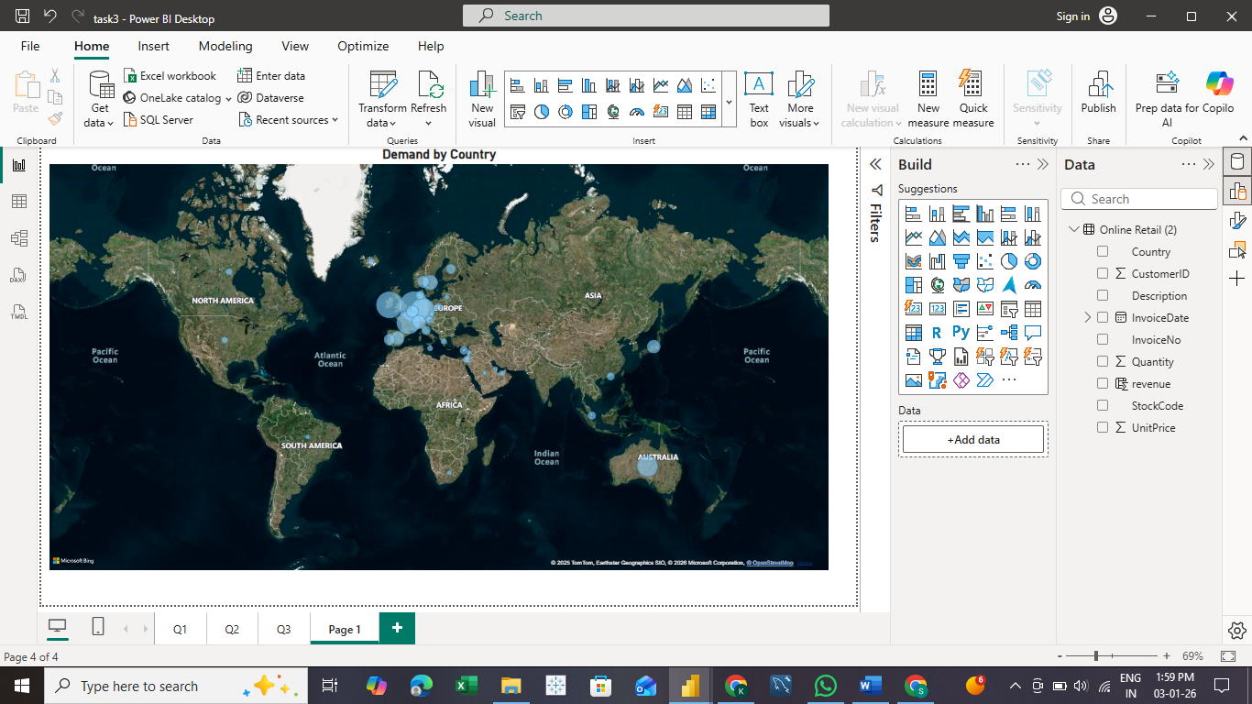
Answer folder: task3.pbix
Task 4:
It’s time to present your findings to the CEO and CMO. They are interested in your thought process and how you have handled the data cleanup and visualisation phase. It is important to explain your thought process and ideas in a clear and straightforward way. You are also required to clearly present the analysis of all four questions from the previous task. Make sure you are well versed with the data and the conclusions you’ve made from your analysis.
Expansion is top of mind for these leaders and they’re keen to understand where the most lucrative opportunities are in their business.
Some resources to help guide you in communicating data effectively are provided in the resources section below.
Develop a script and record a video presenting your findings to the CEO and CMO based on the four questions they asked and the visuals you created in the previous tasks.
You can use your work or the model answer from the previous task to develop your presentation.
When writing your script, you should speak about your entire process, including the initial data load and clean-up steps so that your leaders know you’ve done your due diligence in providing error-free analysis. Data analysis provides heaps of information but remember to focus on the information that is most important to your leaders.
Your video should be approximately 5 minutes in length. You can record your video in the browser or upload a video from your device below.
Remember, this is not just a read out of your visuals, you’re presenting to the CEO and CMO and need to provide context for each scenario and how it relates to their questioning.
Solution
Script:
Good morning, and thank you for the opportunity to present my analysis.
Before creating any visuals, I focused on data cleanup to ensure the insights are accurate and reliable. I identified invalid records where quantities were less than one, indicating returns, and unit prices that were below zero due to data entry errors. Using conditional logic and filters, I excluded these records so that only valid sales transactions were included in the analysis. This ensured that revenue and demand calculations were error-free.
Now, I’ll walk through the four questions you raised.
For Question 1, I analyzed revenue trends for the year 2011 at a monthly level. The time-series visual clearly shows seasonal patterns, with certain months consistently generating higher revenue. These trends help explain customer purchasing behavior and provide a strong foundation for forecasting demand in the following year.
For Question 2, I looked at the top 10 revenue-generating countries, excluding the United Kingdom. Along with revenue, I included quantity sold to provide additional context. This helped identify countries that not only generate high revenue but also demonstrate strong sales volume, highlighting key international markets for growth.
For Question 3, I analyzed the top 10 customers by revenue. The visual is sorted from the highest to lowest revenue-generating customers, making it easy to identify high-value customers. These customers are critical for targeted retention and personalized marketing strategies.
For Question 4, I assessed product demand across all countries, excluding the United Kingdom. Using a single, non-interactive view, the visual clearly highlights regions with the highest demand based on quantity sold. These regions represent strong candidates for expansion opportunities.
To conclude, after ensuring clean and accurate data, the analysis shows clear seasonal revenue trends, high-performing international markets, valuable customer segments, and regions with strong demand. These insights can support strategic decisions around forecasting, customer targeting, and expansion.

Thank you

